Follow this steps to open it via other PC or laptop

Open elixir application to your local PC
1. Teachers login – http://elixir.test
2. Public page – http://elixir.test/public
Open elixir application to other PC or laptop
1. go to run (Windows Key ⊞ + R)
2. run this command cd C:\laragon\www\atomxplor\web && npm run dev -- --host
3.copy and paste network to your web browser
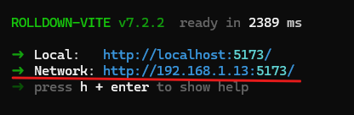

4. To open public page just run this link – http://(your_ip_address):5173/public
5. To open teachers login – http://(your_ip_address):5173/
username: super@admin.com
password: password

